To register your account with the Client Portal.
You will receive an email form thomsonreuters.com.
It will look like this:
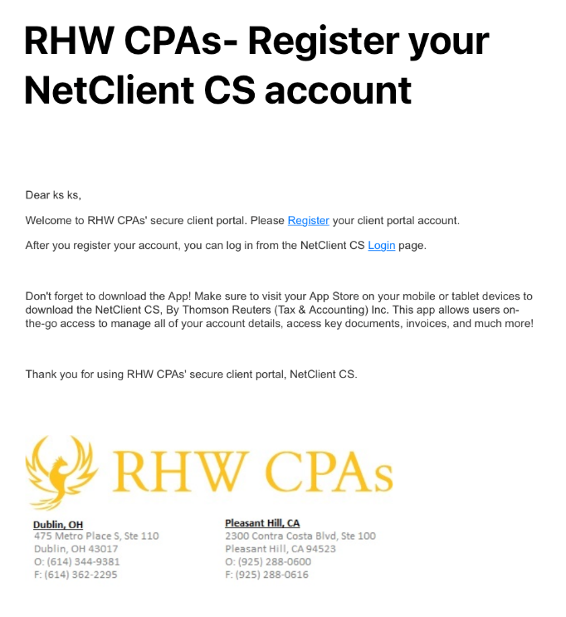
You will want to clink on the “Register” to create a log in and password. It will take you to the site
It will look like this:
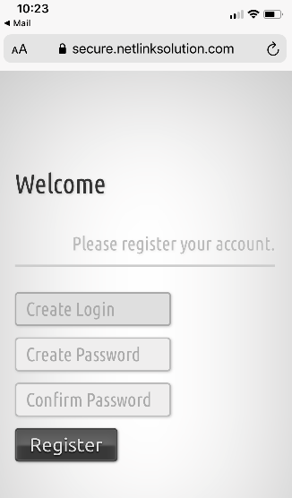
Here you create a log in, you my use whatever you chose.
You will then create a password, be sure to use one that you can remember. Then confirm the password by entering it again,
Then Click the “Register “button.

